Source https://bevacationtravels.com/product/bali-instagram-journey-tour-of-the-gate-of-heaven-temple/
__________________________________________________________

Bali Photo Quest: Gate of Heaven & Hidden Waterfalls Private Tour
__________________________________________________________
★★★★★ 4.7/5 20 reviews

Add to wishlist ♡

__________________________________________________________

Full-Day Experience | €95 per person

🏕  Image | 🏕  Image | 🏕  Image | 🏕  Image | 🏕  Image | 🏕  Image

__________________________________________________________
About This Tour
Capture Bali’s most iconic landscapes and sacred sites on a private sightseeing journey designed for travellers who want stunning views, cultural immersion, and unforgettable photos. This exclusive experience takes you from the famous Gate of Heaven Temple, framed by Mount Agung, to royal water gardens, jungle waterfalls, and lush rice terraces.
With hotel pickup, all entrance fees included, and a private guide accompanying you throughout the day, you can relax and focus on enjoying Bali’s beauty while every detail is handled for you.
__________________________________________________________
What’s Waiting for You
- Duration: 10 hours
- Group Size: Private tour — only your group participates
- Languages Available: English
- Guide: Private driver-guide
- Transportation: Air-conditioned private vehicle
- Fitness Level: Moderate recommended
- Season: Available year-round
- Pickup Locations Complimentary pickup and drop-off available from hotels, villas, or apartments in Ubud, Sanur, Kuta, Legian, Seminyak, Canggu, Nusa Dua, Jimbaran, and Uluwatu.
__________________________________________________________

Check Dates & Availability

Select participants: (Age 99 and younger) - 1 +

Choose date:
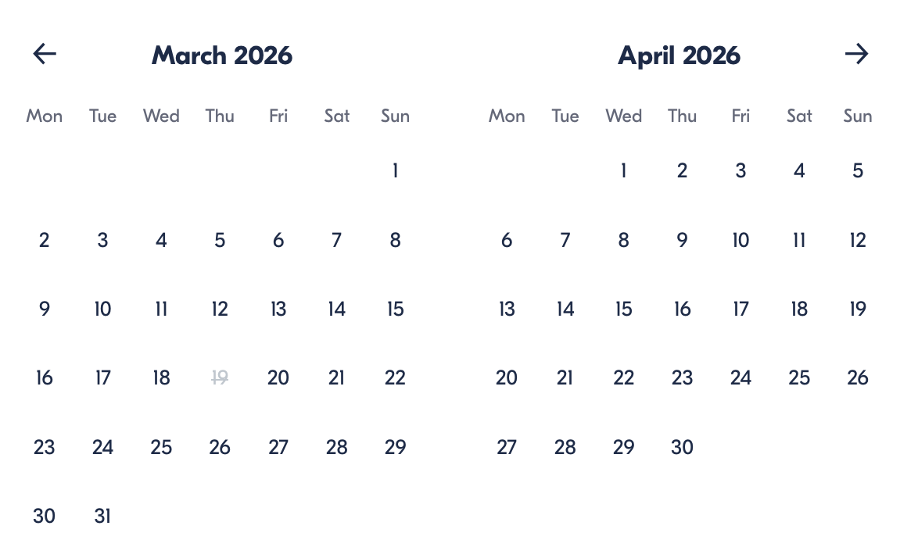

Check Availability

opens:

Participants: 1 March 16, 2026

Bali Photo Quest: Gate of Heaven & Hidden Waterfalls Private Tour

- Start times: 4:00 AM | 6:00 AM | 7:00 AM

Cancellation:

- More than 24 hours before start — Full refund
- 24 hours or less before start — No refund

Price breakdown: 1 Participant x €90

Total: €90

The total price includes all taxes and fees.

Add to cart Book now

__________________________________________________________
Tour Features
- Gate of Heaven Temple: Iconic Bali photo spot with Mount Agung backdrop
- Royal Water Palace: Explore Tirta Gangga’s fountains and gardens
- Hidden Cave Waterfall: Trek to Tukad Cepung’s magical cascade
- Rice Terrace Landscapes: Visit the famous Tegalalang terraces
- Jungle Swing Experience: Soar above greenery for epic photos
- All-Inclusive Entry: No extra ticket costs during the tour
__________________________________________________________
Detailed Itinerary
Lempuyang Temple (Gate of Heaven)
Visit one of Bali’s most sacred temples and capture the legendary photo framed by the mountain volcano. Duration: ~1 hour.
Tirta Gangga Water Palace
Walk through peaceful gardens, pools, and sculptures fed by natural springs. Duration: ~1 hour.
Mahagiri Panoramic Restaurant
Enjoy lunch with scenic views of rice fields and Mount Agung. Duration: ~1 hour.
Tukad Cepung Waterfall
Trek through jungle paths to a hidden waterfall glowing with sunbeams. Duration: ~1 hour.
Tegalalang Rice Terrace
Admire dramatic stepped rice paddies and lush tropical scenery. Duration: ~45 minutes.
d’Alas Jungle Swing
Experience an adrenaline-filled swing above the jungle and rice fields. Duration: ~30 minutes.
__________________________________________________________
Included in Price
- Private tour service
- Hotel pickup and drop-off
- English-speaking driver-guide
- Lunch
- Bottled water
- All entrance fees and donations
- Temple sarong rental
- Jungle swing ticket
__________________________________________________________
Not Included
- Gratuities
__________________________________________________________
Who Should Avoid This Tour
- Pregnant travellers
- Travellers with heart problems or serious medical conditions
- Travellers with back problems
- Wheelchair users
__________________________________________________________
Important Trip Info
- Confirmation received at booking
- Infant seats available
- Moderate physical fitness is recommended
- Expect crowds at Lempuyang Temple
- Minimum age for jungle swing: 10 years
- Private tour — only your group participates
__________________________________________________________

Cancellation Policy
- More than 24 hours before start — Full refund
- 24 hours or less before start — No refund
__________________________________________________________
What Our Clients Are Saying

Overall rating  4.7/5  ★★★★★  Based on 20 reviews | Review summary  Guide 4.5/5  Transportation 4.6/5  Service 4.7/5  Organisation 4.5/5

Filter  - All traveller types  - Couples  - Group of friends  - Families  By star rating  - All star ratings  - 5 stars  - 4 stars  - 3 stars  - 2 stars  - 1 star | Search reviews (e.g., guide)  Sort by:  - Top picks  - Latest reviews  - Best ratings  - Lowest ratings
__________________________________________________________
★★★★★
Sarah T. — Canada
The Gate of Heaven views were unforgettable, and our guide made the whole day smooth and fun.
★★★★★
Chen W. — China
Everything was perfectly organised from pickup to drop-off. Incredible locations.
★★★★★
Emily G. — Australia
So many amazing photo spots in one day. Absolutely loved it.
★★★★★
Javier R. — Spain
The itinerary was perfectly paced, and every stop was beautiful.
★★★★★
Priya P. — India
A magical experience with stunning scenery and fascinating cultural insights.
See more reviews
__________________________________________________________

Meta tags

Page - Bali Photo Quest: Gate of Heaven & Hidden Waterfalls Private Tour

Title: Bali Photo Quest: Gate of Heaven & Hidden Waterfalls Private Tour | Travellio Global

Description: Discover Bali’s most iconic photo spots on a private tour to the Gate of Heaven, Tirta Gangga, Tukad Cepung Waterfall, and rice terraces. All entrance fees, lunch, and transfers are included.

H1 - Bali Photo Quest: Gate of Heaven & Hidden Waterfalls Private Tour
__________________________________________________________

